**MongoDB Day 1**

**Database Name: GUVI-FSD-TASK**

**Collection Name: product**

For the following question write the corresponding MongoDB queries

1. Find all the information about each products

Ans: db.product.find();

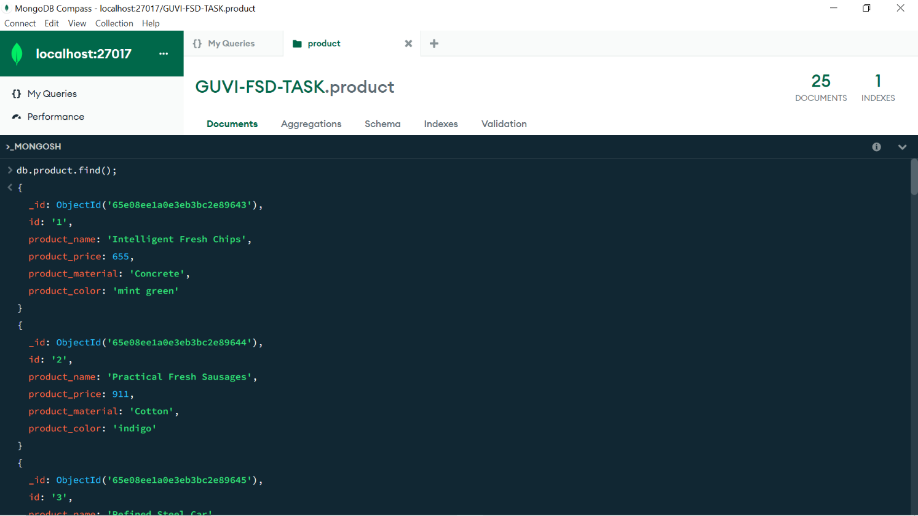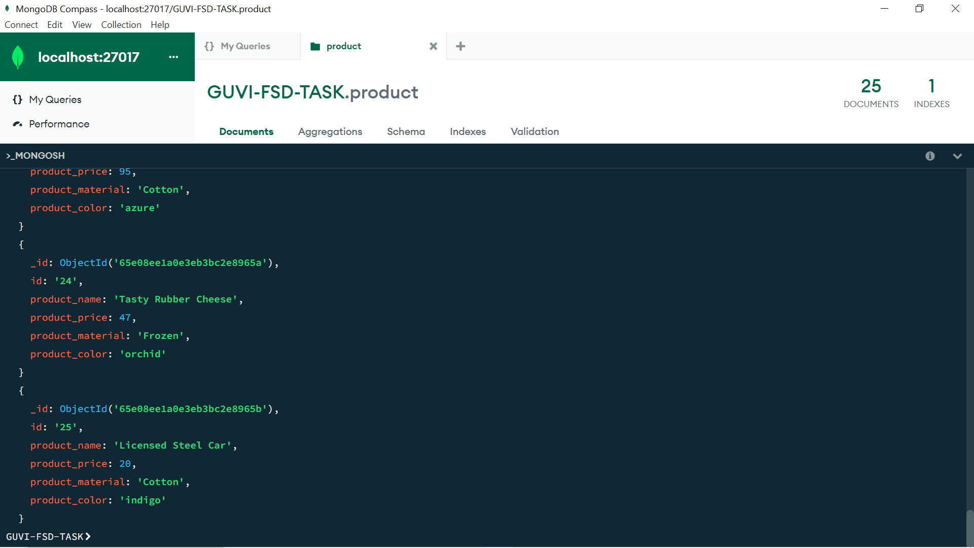

1. Find the product price which are between 400 to 800

Ans: db.product.find({‘product_price’:{$gte:400,$lte:800}});

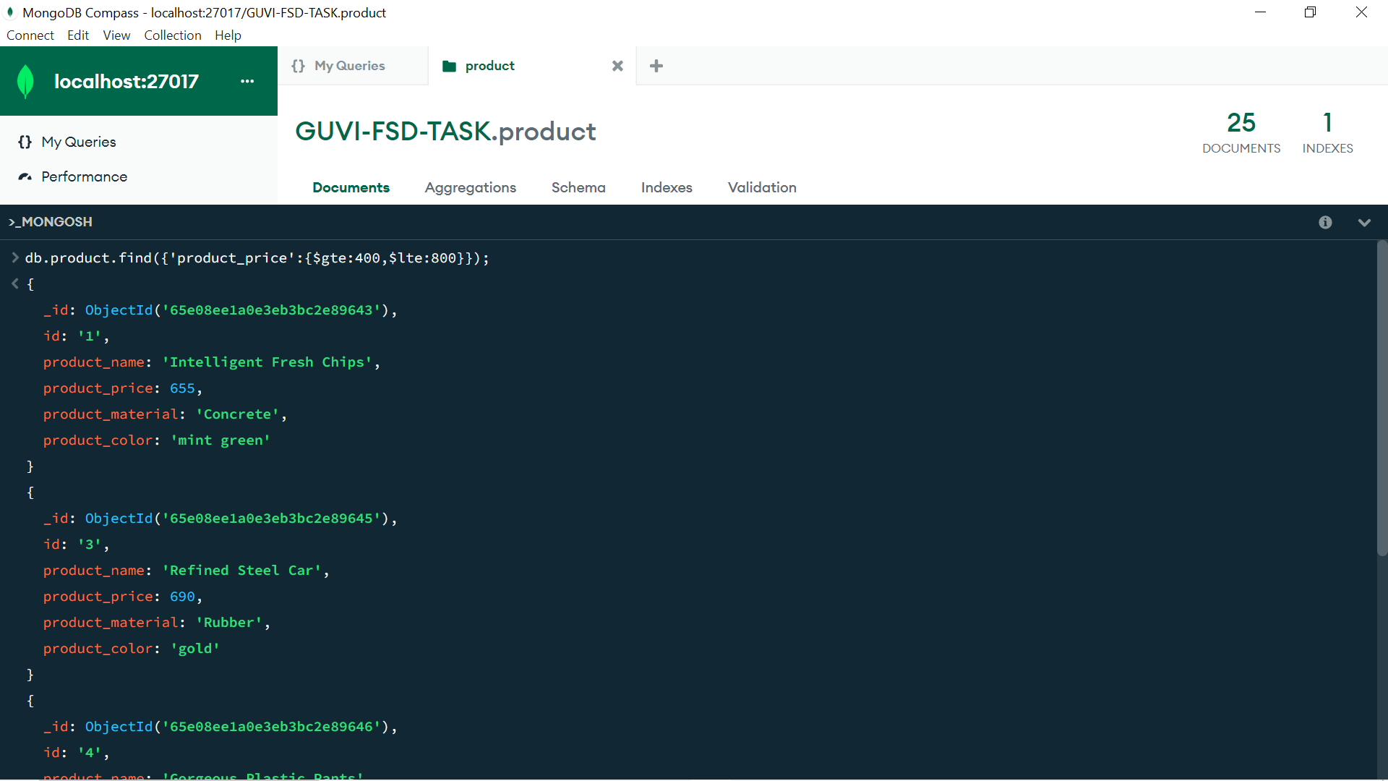

1. Find the product price which are not between 400 to 600

Ans: db.product.find({‘product_price’:{$not:{$gte:400,$lte:600}}});

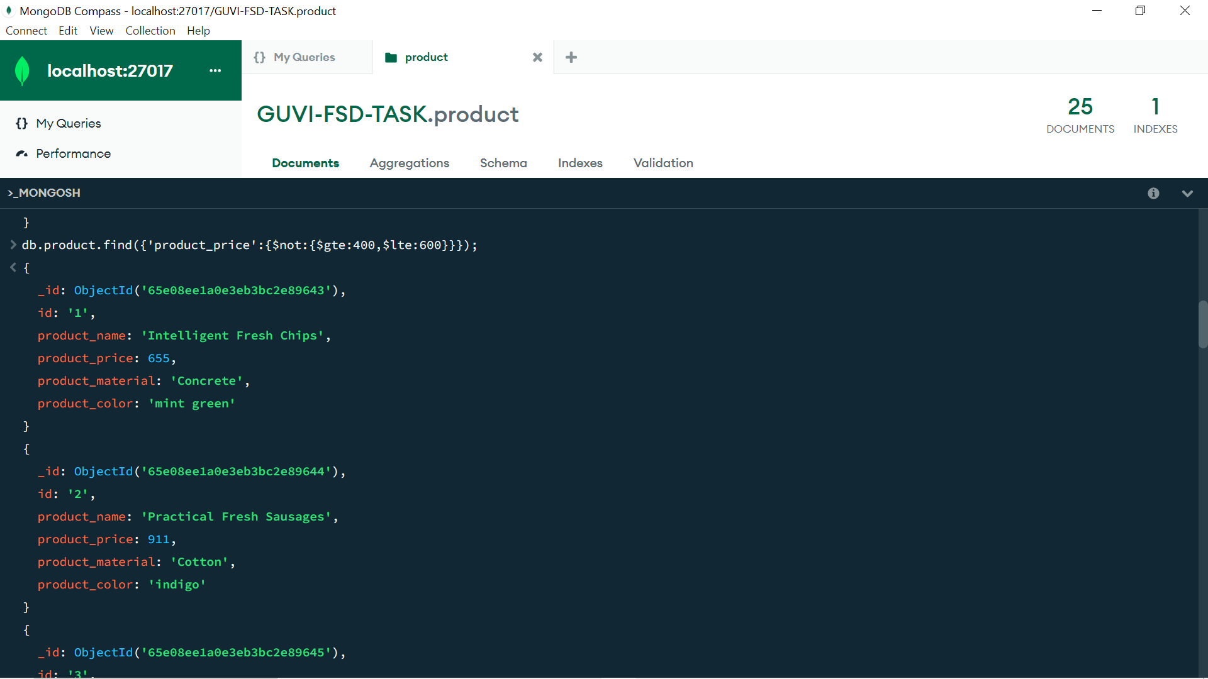

1. List the four product which are greater than 500 in price

Ans: db.product.find({‘product_price’:{$gt:500}}).limit(4);

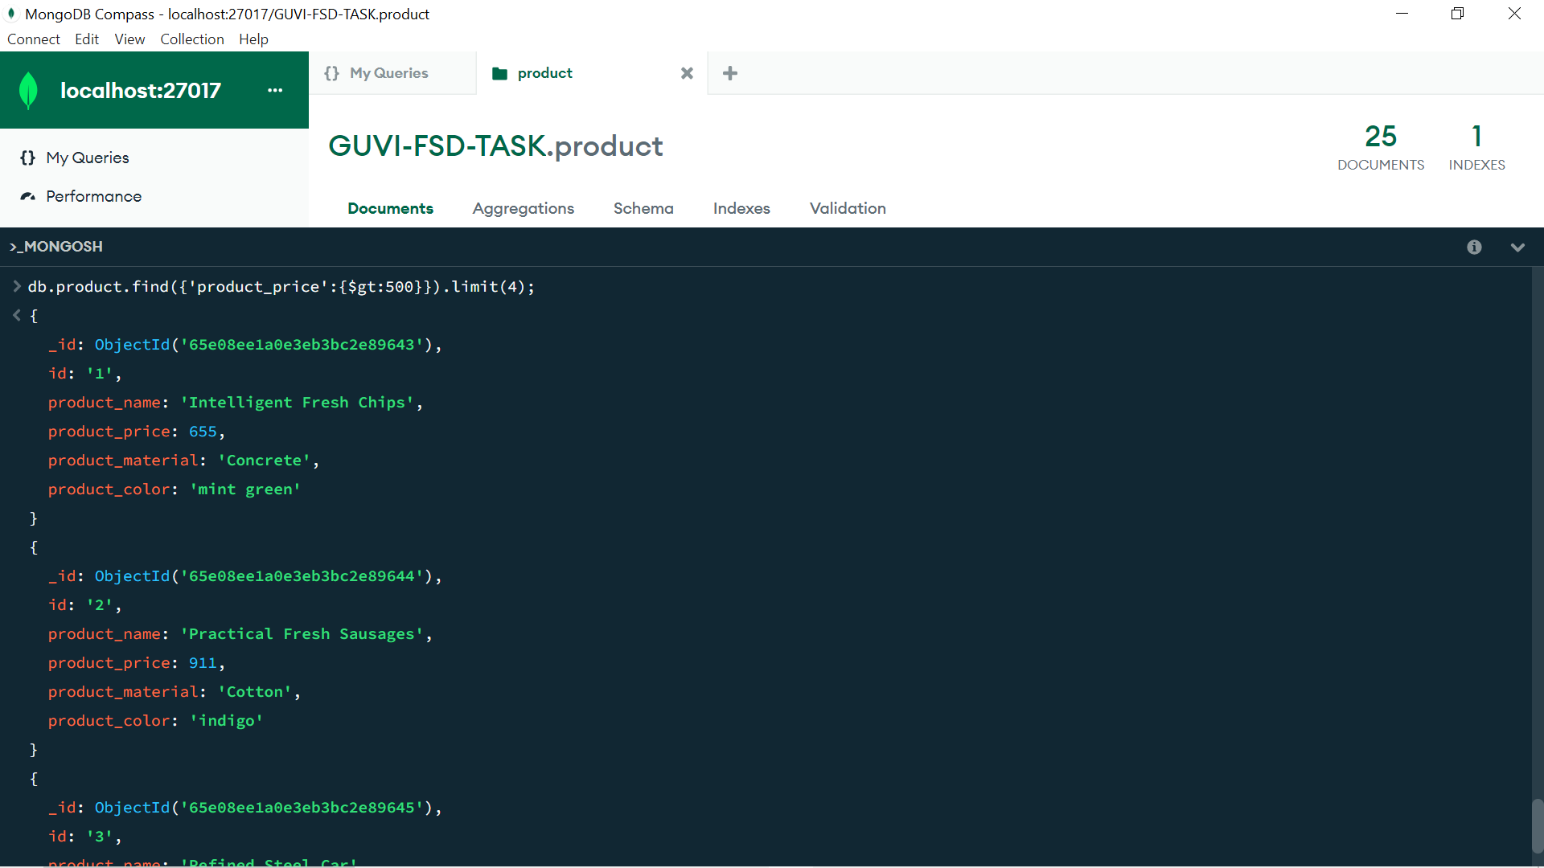

1. Find the product name and product material of each products

Ans: db.product.find({},{‘product_name’:1,’product_material’:1});

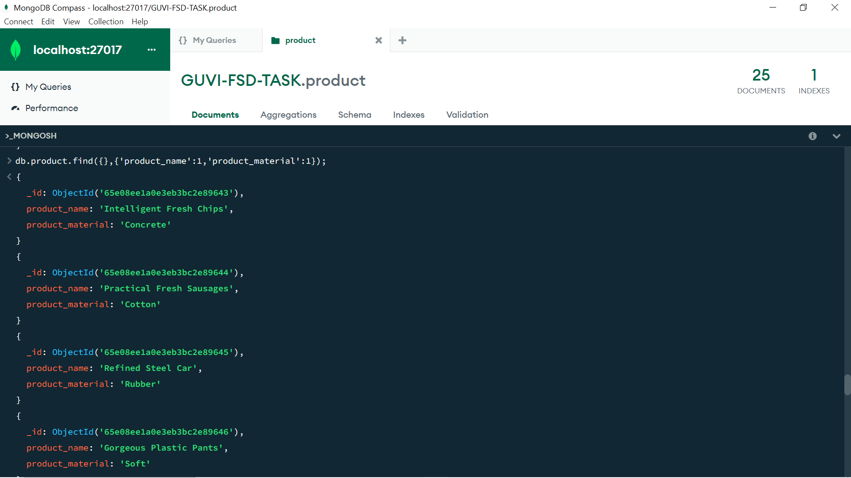

1. Find the product with a row id of 10

Ans: db.product.find({'id':'10'});

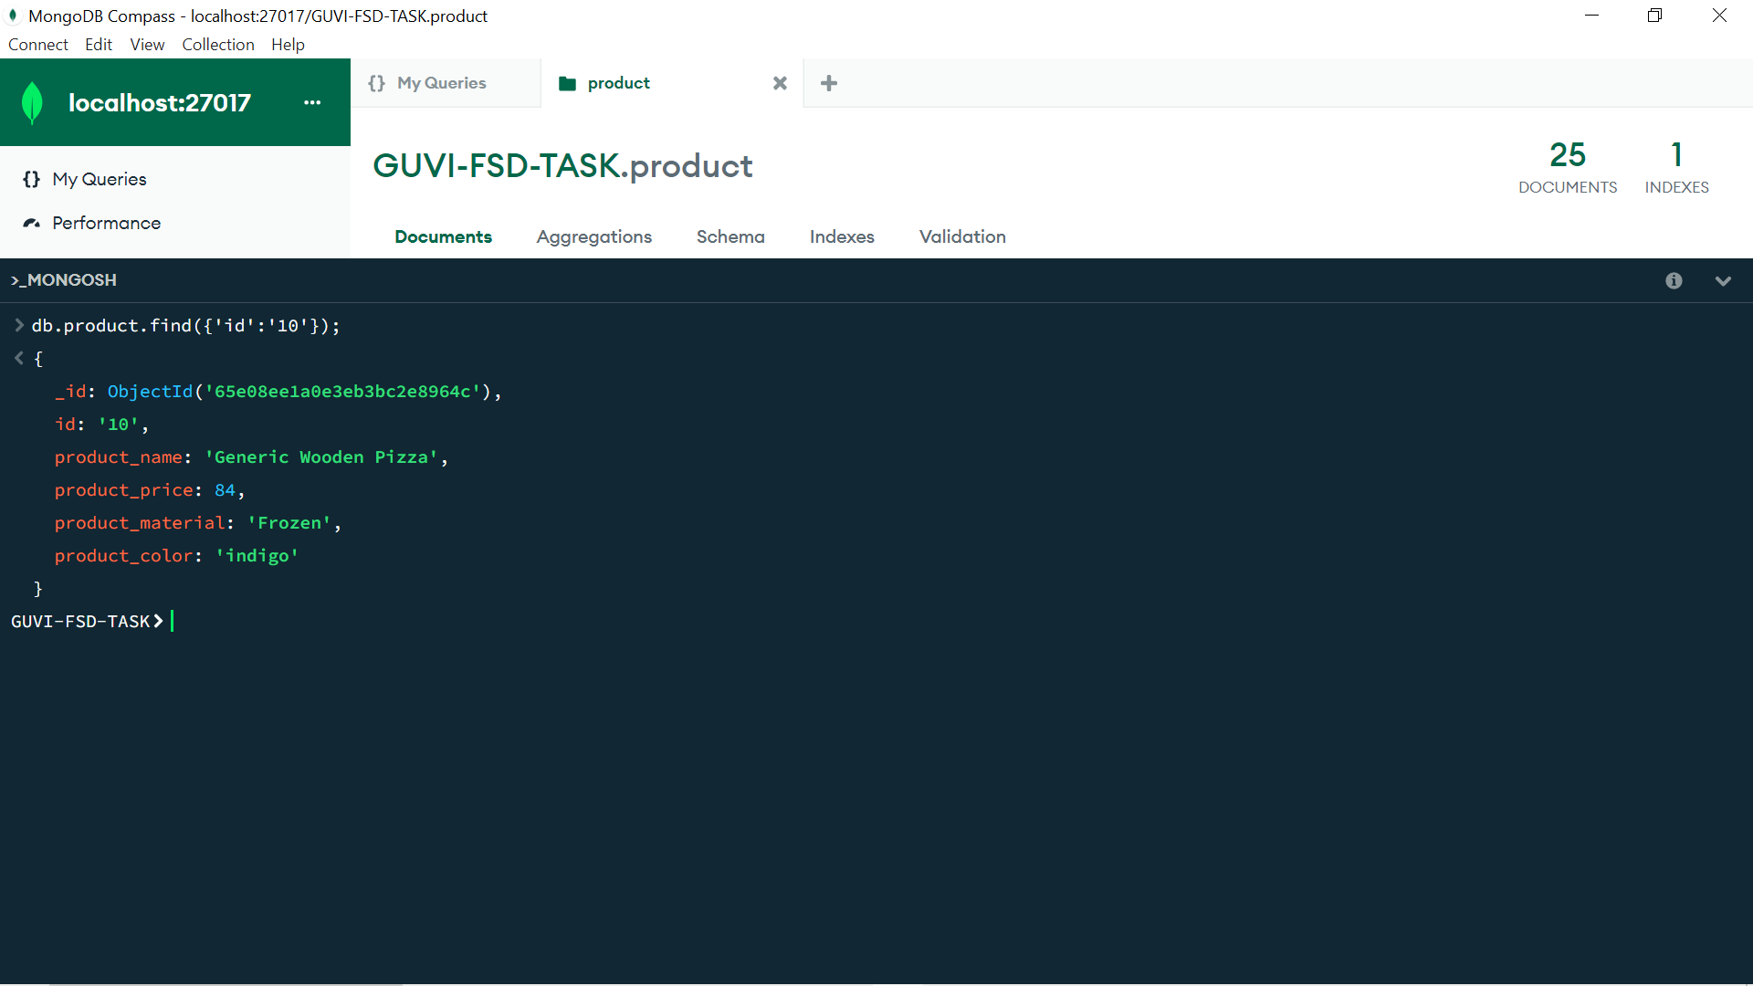

1. Find only the product name and product material

Ans: db.product.find({},{'_id':0,'id':0,'product_price':0,'product_color':0});

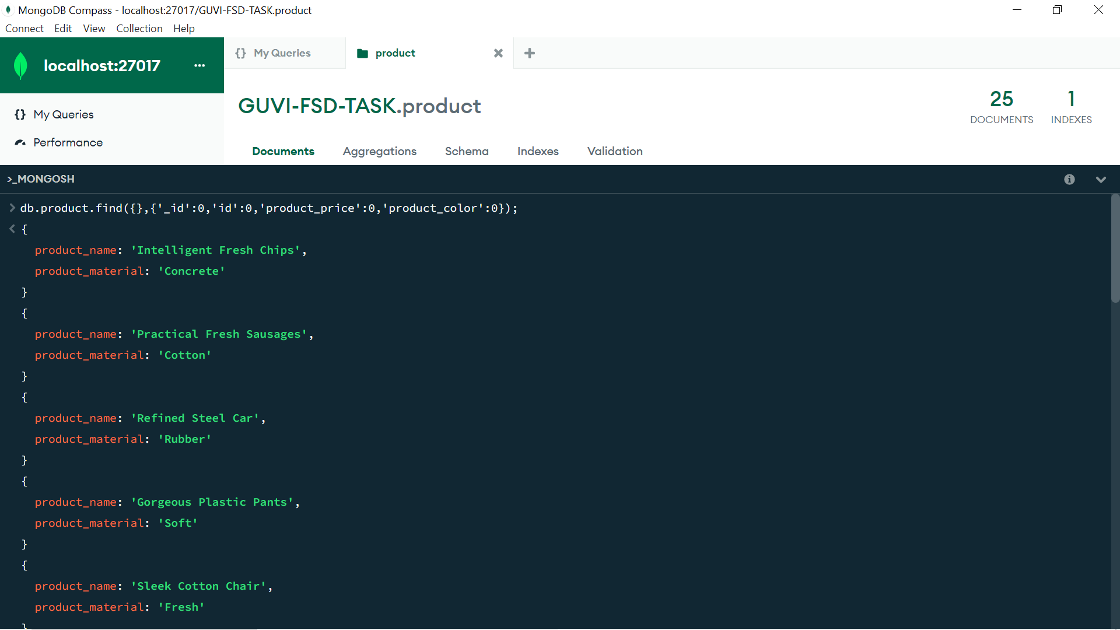

1. Find all products which contain the value of soft in product

Material

Ans: db.product.find({'product_material':'Soft'});

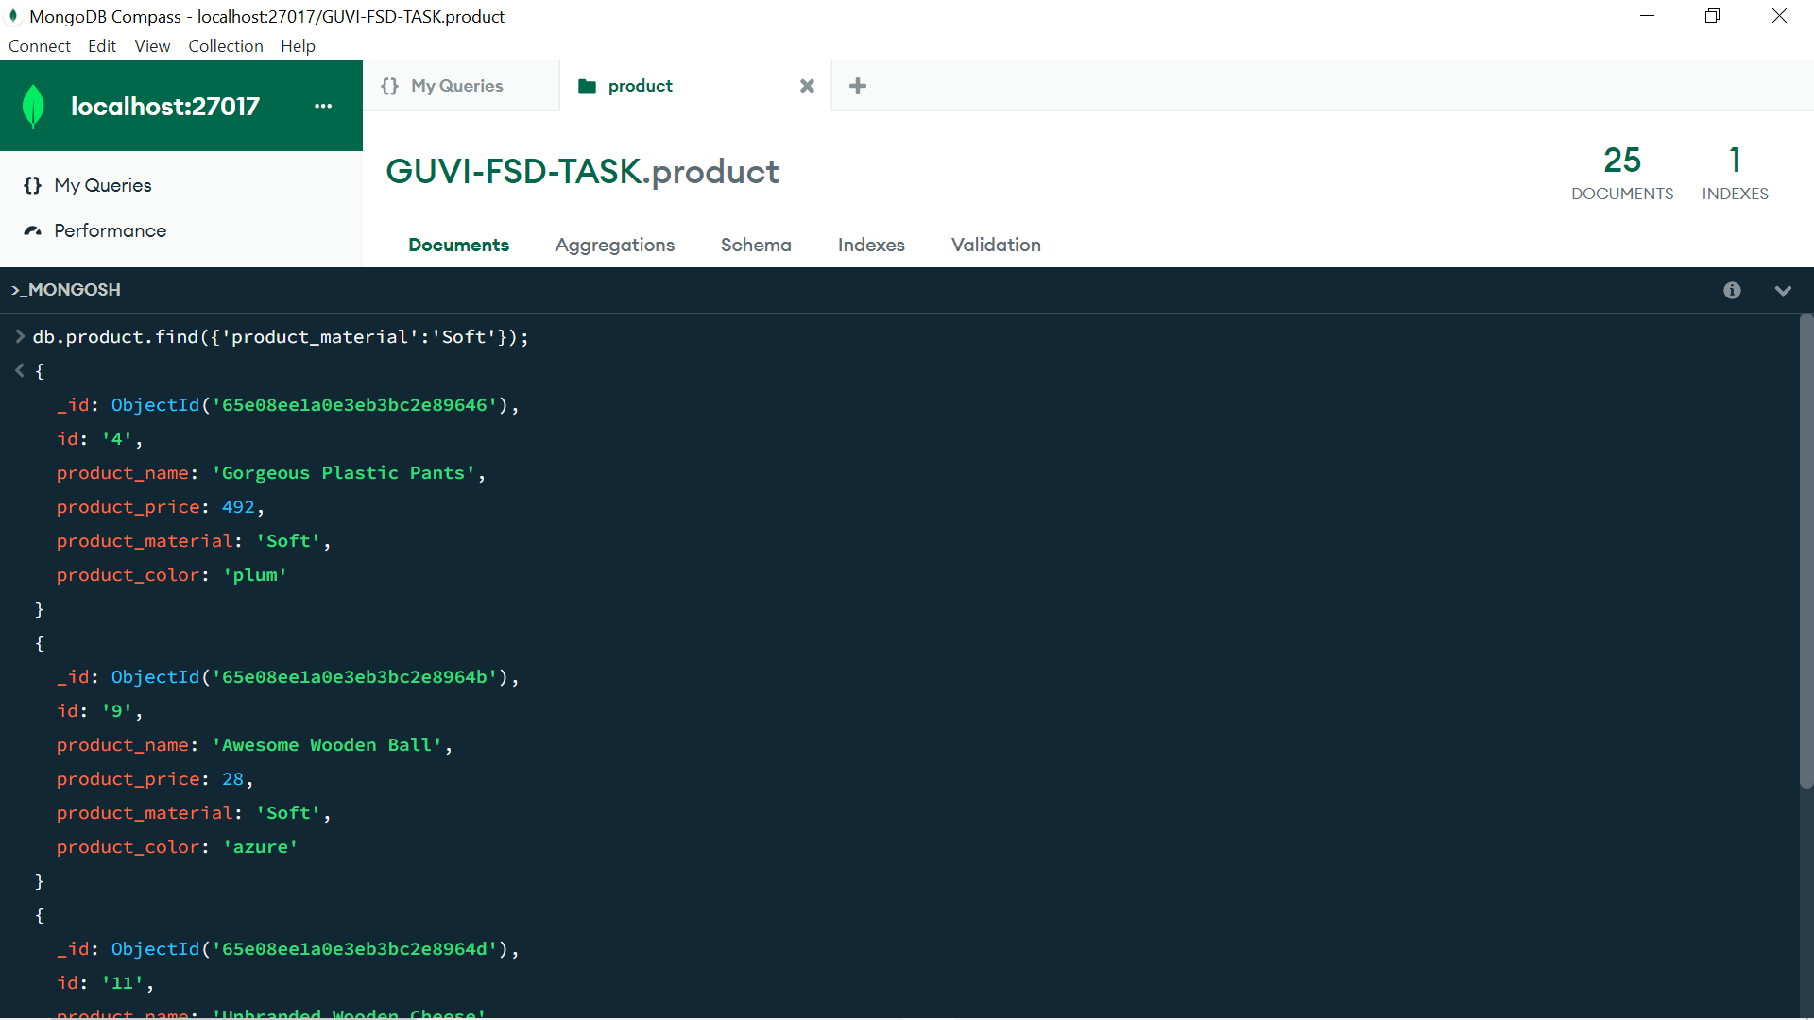

1. Find products which contain product color indigo  and product price 492.00

Ans: db.product.find({$and:[{'product_color':'indigo'},{'product_price':492}]});

Output: No products are match for the given condition.

1. Delete the products which product price value are same

Ans: db.Products.aggregate([ { $group: {_id: '$product_price',

count: { $sum: 1 } } }, { $match: { count: { $gt: 1 } } } ] ).forEach((e)

=> { db.Products.deleteMany({ product_price: e._id });});

Output: Product with ‘id’ 16, 17, 20 and 24 are deleted.

